**DBS 301-LAB1 Section: D Prof: Nebojsa Conkic**

**Name: Muhammad Shaher Yar Ahmed ID: 126330166**

1. True

2.True

3. True

4. There are THREE coding errors in this statement. Write the correct syntax

Correction:

select last_name as LNAME,

job_id as "Job Title"

from employees

where job_id = 'SA_REP'

AND salary not between 4000 AND 8000;

5. Show the structure of the LOCATIONS table. Then create a query to display the

output shown below. Be careful, you need to get the exact output.

**Structure for Locations:**

**SQL:** DESCRIBE LOCATIONS;

**OUTPUT:**

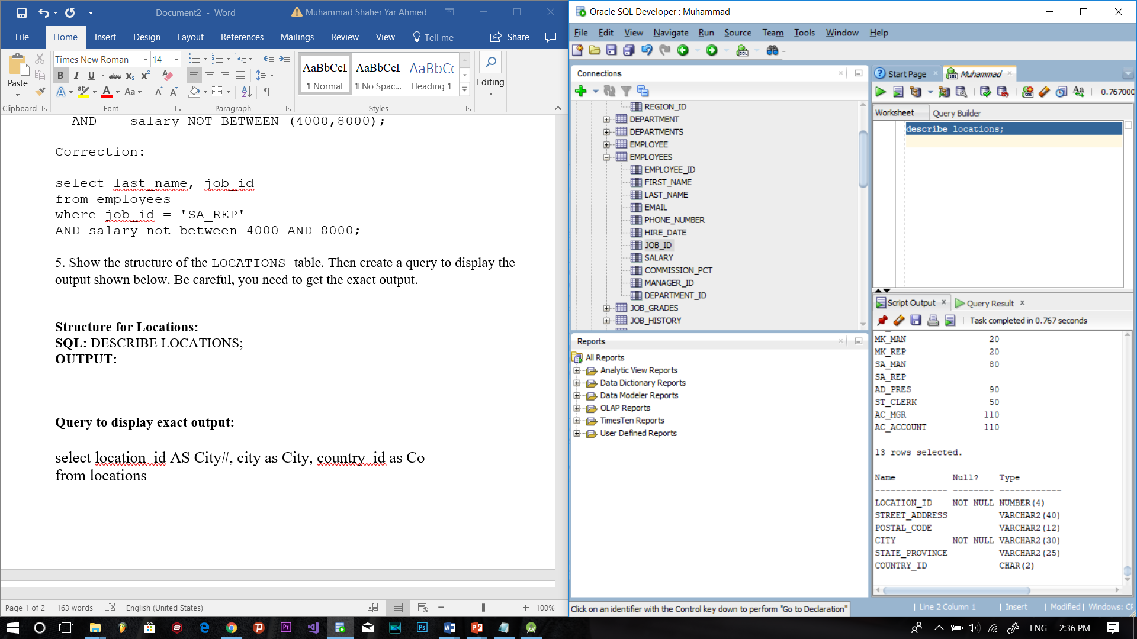

**Query to display exact output:**

select location_id as City#, city as City, country_id as Co

from locations

where location_id between 2100 and 3200

order by city;

OUTPUT:

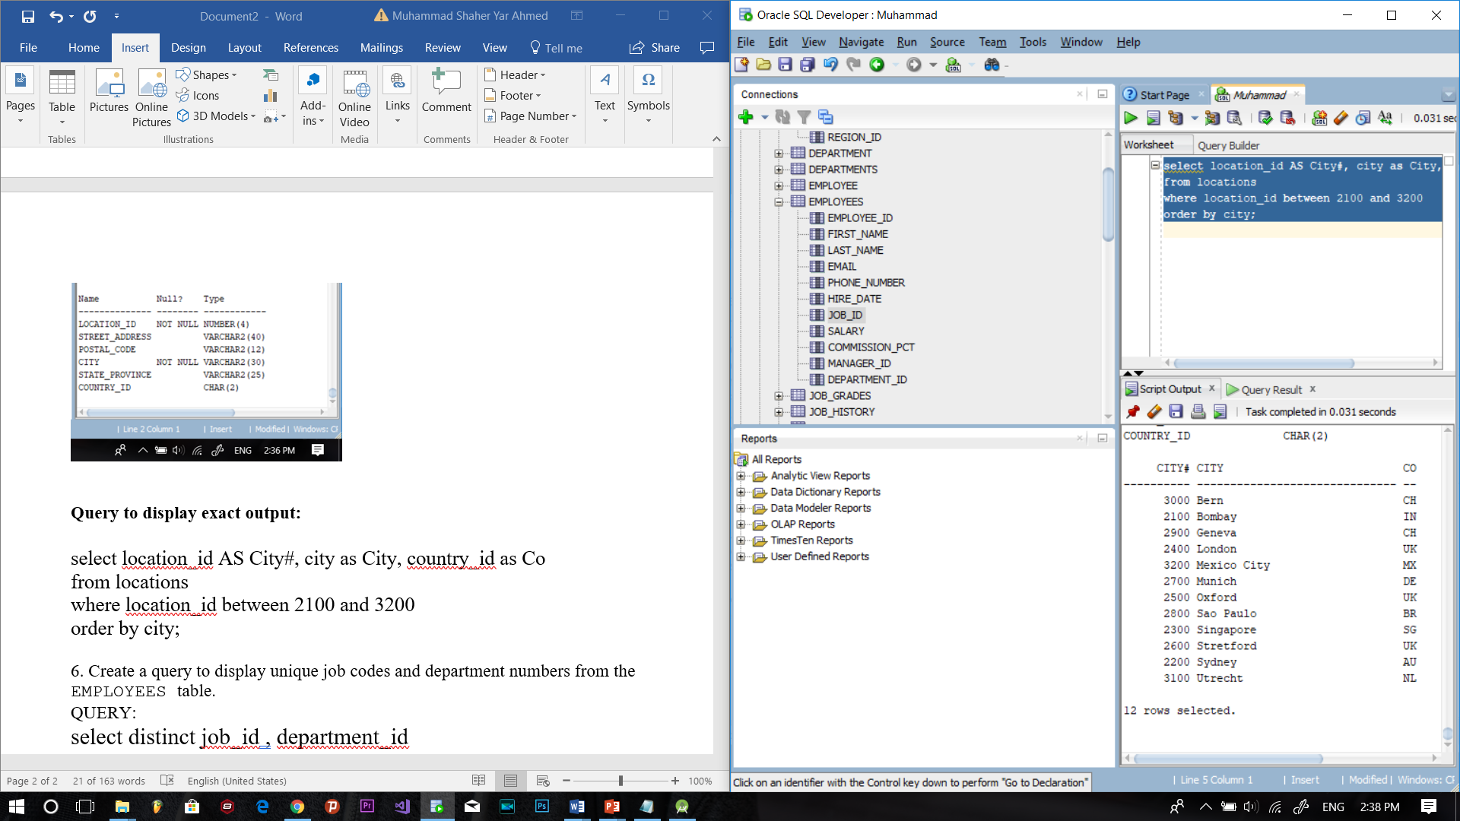

6. Create a query to display unique job codes and department numbers from the EMPLOYEES table.

QUERY:

select distinct job_id , department_id

from employees;

Output:

